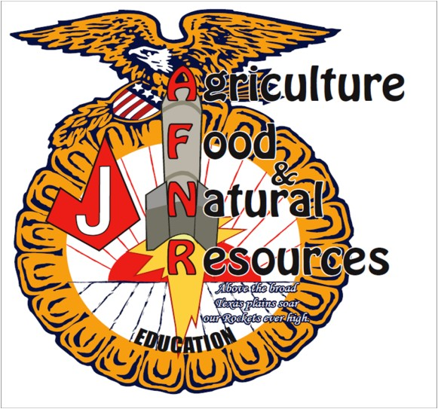

Judson Agriscience Program

2020-2021

Agriculture Science Instructors/Advisors

Mr. Jay Trees jtrees@judsonisd.org

Ms. Lauren Henderson lhenderson@judsonisd.org

Ms. Kelly Verstuyft kverstuyft@judsonisd.org

Mrs. Brittany Esparza
besparza@judsonisd.org

Ms. Sondra Lohse
slohse@judsonisd.org

Mrs. Kristin Rumfield
krumfield@judsonisd.org

Chapter Officers

PRESIDENT Sam Perez
VICE PRESIDENT Damien Luna
TREASURER Charla Wiemers PUBLICITY
Desi Mosemeyer
REC SECRETARY
Ja’Net Hayes
COOR SECRETARY
Becky Wilson
PROJECT COOR
Laura Bennet

Dear Supporter of the Judson FFA:

The Judson FFA Parent/Alumni Association is looking for community minded businesses or individuals like you to help the Parent/Alumni support of our youth involved in the Judson FFA program.

We would appreciate your assistance with donations toward the Silent Auction or Raffle at our
Annual Judson FFA Chapter Show or one of the many events we organize in support of the Judson FFA.

The Judson FFA Parent/Alumni will use proceeds raised from all events to help our FFA students and teachers in areas of educational enhancement, scholarships, student recognitions, Stock Show support and facility support.

All sponsors will get advertising on our sponsor banner and will be recognized in our program and at our year-end banquet. Your donation to this organization will be tax deductible. The Judson FFA Alumni is a 501 © (3) organization, tax ID number 26-0133852.

The Judson FFA Parent/Alumni Association may be contacted for further information at JUDSONFFAALUMNI@gmail.com or to pick up your gracious donation, you may contact Jay Trees @ 210-945-1100, Sam Perez @ 210-602-7502, or Charla Wiemers @ 210-416-2018.

On behalf of the Judson FFA Parent/Alumni Association, we thank you for your support of the youth in our community.

Thank you,
Sam Perez
Judson FFA Parent/Alumni Association President

*PLEASE ATTACH THIS LOWER PORTION TO THE DONATION ITEM* Business Name: Contact Person: Business Address:
City: State: Zip: Description of Item:
Donation Value: A donation receipt will be mailed to your business.

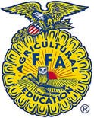

The FFA Mission

FFA makes a positive difference in the lives of students by developing their potential for premiere leadership, personal growth, and career success through agricultural education.

Est. 1959

9142 FM 78 Converse, TX 78109 • (210) 945-1100 ext. 19600 • Fax (210) 659-4359 • www.judson.ffanow.org

